**Air Canvas and Virtual Computer System**

Submitted in partial fulfillment of the requirements

of the degree of

Bachelor of Engineering

in

Computer Engineering

by

*Darshan Patel 118A1020*

*Kriti Kakkar 118A1032*

*Harshitha Moolya 118A1048*

Under the Guidance of:

*Prof. Masooda Modak*



Department of Computer Engineering

SIES Graduate School of Technology

2021-2022

**CERTIFICATE**

This is to certify that the project entitled **“*Air Canvas and Virtual Computer System*”** is a bonafide work of the following students, submitted to the University of Mumbai in partial fulfillment of the requirement for the award of the degree of **Bachelor of Engineering** in **Computer Engineering.**

***Darshan Patel 118A1020***

***Kriti Kakkar 118A1032***

***Harshitha Moolya 118A1048***

Prof. Masooda Modak Dr. Aparna Bannore Dr. Atul Kemkar

Internal Guide Head of Department Principal

**PROJECT REPORT APPROVAL**

This project report entitled ***Air Canvas and Virtual Computer System*** by following students is approved for the degree of ***Bachelor of Engineering*** in ***Computer Engineering***

***Darshan Patel 118A1020***

***Kriti Kakkar 118A1032***

***Harshitha Moolya 118A1048***

**Name of External Examiner: --------------------------------**

**Signature:--------------------------------**

**Name of Internal Examiner: --------------------------------**

**Signature:--------------------------------**

**Date:**

**Place:**

**DECLARATION**

I declare that this written submission represents my ideas in my own words and where others’ ideas or words have been included, I have adequately cited and referenced the original sources. I also declare that I have adhered to all principles of academic honesty and integrity and have not misrepresented or fabricated or falsified any idea/data/fact/source in my submission. I understand that any violation of the above will be cause for disciplinary action by the Institute and can also evoke penal action from the sources which have thus not been properly cited or from whom proper permission has not been taken when needed.

Darshan Patel 118A1020 _____________

Kriti Kakkar 118A1032 _____________

Harshitha Moolya 118A1048 _____________

Signature

Date:

**ACKNOWLEDGEMENT**

We wish to express our deep sense of gratitude and thanks to our Internal Guide, Prof. Masooda Modak for her guidance, help and useful suggestions, which helped in completing our project work in time. We also thank our HOD Dr. Aparna Bannore for her support in completing the project. We also thank to our Principal Dr. Atul Kemkar, for extending his support to carry out this project

Also we would like to thank the entire faculty of the Computer Engineering department for their valuable ideas and timely assistance in this project. Last but not the least, we would like to thank our teaching and non teaching staff members of our college for their support, in facilitating timely completion of this project.

**Project Team**

Darshan Patel

Kriti Kakkar

Harshitha Moolya

**ABSTRACT**

In today's world the field of Computer Vision and Artificial Intelligence has contributed immensely towards development of applications related to augmented reality, Gesture control systems, etc. The work proposed here explains how to draw and write English text in front of a camera using a real-time video-based pointing technique. To achieve the purpose, the proposed system combines color recognition and tracking to track the coloured finger tip in video frames. A mask is formed when a color marker is detected. It includes two stages of the morphological process. Erosion and Dilation are two procedures performed on the mask. Impurities are reduced through erosion present in the mask, and dilation helps to repair the primary mask's deteriorated condition.The user will even be able to select the colors that will be shown in the suggested system. The camera will be triggered when the programme is started, allowing the user to draw in the air just by waving the tracker item. The artwork is also visible on the white window at the same time. Instructor can choose any color of his choice displayed in the system’s color palette to draw and also can clear the screen when needed. We will be using the computer vision techniques of opencv and python to build this application. Also, our system includes virtual keyboard and virtual mouse.The proposed framework for virtual keyboard is vision-based, and it makes use of AI technologies as well as input from a PC webcam.The Virtual Mouse detects finger movements to control the cursor using basic motions and hand control without the need for extra hardware. This is accomplished by combining webcam inputs with vision-based hand gesture detection. We intend to develop a full-pledge app which will include all these features.

**Contents**

|  |  | **Page No.** |
| --- | --- | --- |
| **Chapter 1** | **Introduction** | **1-4** |
|  | **1.1 Need of project** | **1** |
|  | **1.2 Scope** | **2** |
|  | **1.3 Gnatt chart** | **3** |
|  | **1.4 Organization of the report** | **4** |
| **Chapter 2** | **Literature Survey** | **5-8** |
|  | **2.1 Existing System Survey** | **5** |
|  | **2.2 Problem Statement** | **8** |
|  | **2.3 Objectives** | **8** |
| **Chapter 3** | **Proposed System** | **9-16** |
|  | **3.1 System components** | **10** |
|  | **3.2 System functionality** | **16** |
| **Chapter 4** | **Design and Methodology** | **17-22** |
|  | **4.1 System design** | **17** |
|  | **4.2 Hardware and Software requirements** | **22** |
| **Chapter 5** | **Results and Discussions** | **23-26** |
| **Chapter 6** | **Conclusion and Future scope** | **27** |
| **References** |  | **28-29** |

**List of Figures**

| **Figure**  **No.** | **Figure Caption** | **Page**  **No.** |
| --- | --- | --- |
| **1** | **Gantt Chart** | **3** |
| **2** | **Air Canvas System block diagram** | **10** |
| **3** | **Real Time use of openCV** | **11** |
| **4** | **Hand Landmark model** | **14** |
| **5** | **System framework block diagram** | **15** |
| **6** | **Activity diagram of Air Canvas System** | **17** |
| **7** | **Use Case diagram of Air Canvas System** | **18** |
| **8** | **Flow chart of Air Canvas System** | **19** |
| **9** | **Data flow diagram of virtual keyboard and mouse system** | **20** |
| **10** | **Flow chart of Virtual keyboard and mouse system** | **21** |
| **11** | **Snapshot of Air canvas system** | **23** |
| **12** | **Snapshot of virtual keyboard system** | **24** |
| **13** | **Snapshot of virtual keyboard system** | **25** |
| **14** | **Experimental result of virtual keyboard** | **26** |

**CHAPTER 1 INTRODUCTION**

In the era of the digital world, traditional art of writing is being replaced by digital art. Digital art [12] refers to forms of expression and transmission of art in digital form. Air Canvas is a hands-free digital drawing tool that uses a technique of AI based components like OpenCV to draw and perform different functionalities on the screen using hand gestures.

In our project, we have implemented mouse control events, keyboard control using hand gesture recognition. It's a system that performs image processing, retrieves needed details, and then adds them to the computer's mouse and keyboard interface using predefined notations. Our aim is to develop a full-fledged app which operates without peripheral input devices.

**1.1 Need of Project**

The idea of implementing a virtual computer system was made in order to take precautionary measures and protect our systems against malicious keylogger programs.It is fair to say that the Virtual Mouse and keyboard will soon to be substituting the traditional physical mouse and keyboard in the near future, as people are aiming towards the lifestyle where that every technological devices can be controlled and interacted remotely without using any peripheral devices such as the remote, keyboards, etc. it doesn't just provides convenience, but it's cost effective as well

The initial motivation for air canvas came when there was a need for a dustless class room for the students to study in. We know that there are many ways like touch screens and more but what about the schools which can’t afford to buy such huge large screens and teach them like a T.V. This Project will also implement a fun-way of teaching and learning which will enable students to get a clear idea of the concepts.

**1.2 Scope**

The scalability scope in software engineering has always been immense, talking about this project here are some of the future scopes we would like to take up and present:

* Further this technology can be extended to home automation by controlling switch boards such as lights on or off with the gesture.
* Text to Speech feature- specially designed for physically impaired.
* Keyword to image (from web) for better demonstration of concepts and ideas.
* Build Robotic arms and other useful objects which can be visually controlled using gestures.

**1.3 Gantt Chart**

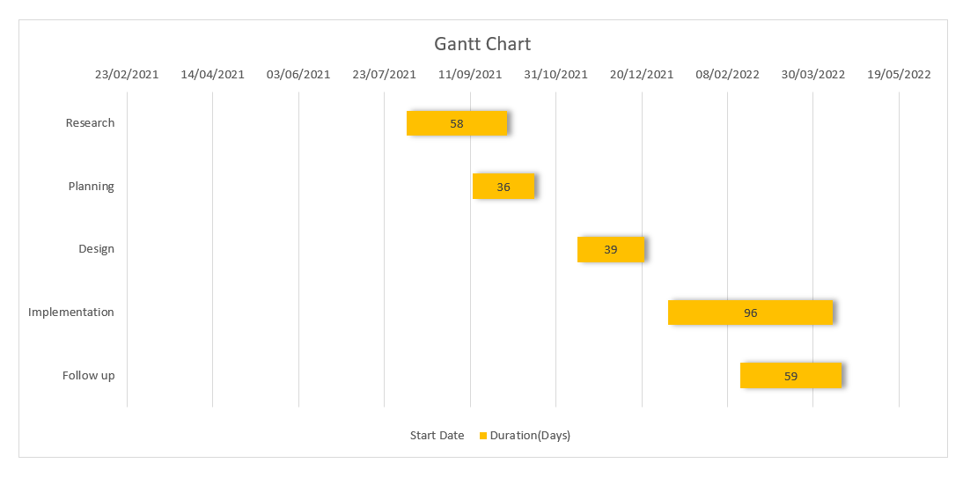

**Figure 1**

**1.4 Organization of the report:**

Chapter 1 gives an introduction of the project. Chapter 2 provides a brief description of the literature survey. Chapter 4 defines the proposed system. Chapter 4 provides details of Design and Methodology. Chapter 5 discusses the results. Chapter 6 explains the conclusion and Future scope of the project.

**CHAPTER 2 LITERATURE SURVEY**

**2.1 Literature survey of an Existing Systems**

**2.1.1 Air Canvas Application Using Opencv And Numpy In Python [1]**

This project proposed in[1] is a reporter of occasional gestures. It used computer vision to trace the path of the finger. The generated text was used for various purposes, such as sending messages, emails, etc. It will be a powerful means of communication for the deaf. It is an effective communication method that reduces mobile and laptop usage by eliminating the need to write. The drawback of the system was that use of character Recognition which was time consuming and Complex.

**2.1.2 An Implementation of Virtual Reality Application of Cursor Control Using Webcam [5]**

The system proposed in [5] uses a well known library for image processing, known as, openCV in the form of emguCV which is a .NET wrapper of it. First of all the application tries to catch a video input device. If it is successful in doing so, it calls the function ProcessFramAndUpdateGUI() where all the processing is done.

The gaps noticed were that the system can’t fully eliminate the need of mouse and keyboard completely. This work aims to build an interactive computer system which can be operated without any physical mouse and keyboard.

**2.1.3 Virtual Keyboard [8]**

The implementation [8] is done with the use of DIP . A projector is used for projecting the image of a keyboard and camera was used for image acquisition purposes. Processor is used to process the image captured by the camera. The purpose of a .NET platform software was frame extraction.But the drawback of the system was that it supported only single touch.

**2.1.4 An Interactive Computer System with Gesture-Based Mouse and Keyboard [6]**

The aim of this paper [6] is to implement a computer application which uses alternative methods to control keyboard and mouse cursors for rehabilitation of people who are suffering from stroke so that they can recover from the side effects.

But the drawback is that the system performs less accurately in a low light condition. Moreover, the work can be extended for a wide variety of environments and can be tested using the sophisticated existing models.

**2.1.5 Text Writing in Air [2]**

The system proposed [2] consists of the following steps. It tracks the motion of the colored finger tip, find its coordinates and plot the coordinates. After plotting coordinates optical character reorganization (OCR) is applied on plotted image, the output is matched with trained database for OCR and the most possible match is achieved and displayed. The drawback of existing system is that it is color sensitive in such a way that existence of any red color in the background before starting the analysis can lead to false results.

**2.1.6 Virtual Mouse using Hand Gestures [4]**

In the system proposed in [4] , the virtual mouse establishes a virtual connection between the user and the machine without the use of any hardware. This gesture recognition system can capture and track the fingertips of a person wearing a color cap with a webcam, and the system detects the hand's color and movements and moves the cursor along with it. The issue with this was that the majority of the applications necessitate the need of additional hardware and specialized operating system, which can be quite costly.

**2.1.7 A Camera Based Virtual Keyboard with Touch Detection by Shadow Analysis [7]**

In this system[7], a webcam looks down on a user's hands, which rests on a paper keyboard template. The program collects images from the webcam to determine when and where the user touches the keyboard template. When the user touches a key, the program produces the corresponding letter as output.This system had some difficulties in fingertip identification.The system does not deliver dependable performance when two fingers are merged into a single region or when one finger excludes another.

**2.1.8 Virtual Painting with Opencv Using Python [3]**

The paper in [3] proposed was based on image processing and feature extraction.OpenCV library was used to track an object-of-interest (a bottle cap in this case) and allows the user to draw by moving the object, which makes it both awesome and challenging to draw simple things. The System proposed has limited application; it can only be used to sketch,but no inbuilt shapes or other features present in it.

**2.2 Problem Statement**

The aim of this project is to develop an AI based tool(Air Canvas) using techniques of OpenCV which can draw anything on a screen by just capturing the motion of a finger or virtual pen with a webcam, and to build a virtual computer system that uses hand gestures to perform various functions.

**2.3 Objectives**

* To create a virtual canvas to sketch,perform morphological operations and to also include different types of shapes so that the user can directly use them by picking and dragging them virtually.
* To implement Virtual Keyboard.
* To implement a Virtual Mouse system.
* To develop a full-pledge app in order to make use of this amazing tool.

**CHAPTER 3 PROPOSED SYSTEM**

The proposed system comprises of various modules such as Air canvas, Mouse and Keyboard System, etc. We have developed a fully-fledged system which performs various functionalities of all these modules integrated in a systematic manner. The system uses computer vision and artificial intelligence based techniques for implementation.

The proposed system overcomes the drawbacks of existing systems by use of Gesture Recognition technology. The proposed system overcomes the drawback of the system discussed in [6] by use of hand gesture detection, in which the system will function smoothly even in low-light condition or blur environment. The system also overcomes the drawback of existing systems that required special objects like rubber cap or pen cap to track the motion and detect objects, but our system will control motion and detection using waving of hand gestures only. Also Our proposed system has the feature of shapes along with multiple color options which provides a more user friendly experience. The system developed may be used by teachers as an alternative to white board. The system would be beneficial for blind people also as they would be able to express their thoughts or ideas by just performing gesture movements.

**3.1 System Components:**

The proposed system comprises of various modules such as Air canvas, Virtual keyboard and Virtual mouse system.

**3.1.1 Air Canvas System:**

We use the computer vision techniques of OpenCV to build this system. Here Hand Detection and tracking is used in order to achieve the objective. The hand gesture recognition is used for hand detection and feature extraction. It includes the further steps of morphological operations on the mask produced which are Erosion and Dilation. Erosion reduces the impurities present in the mask and dilation further restores the eroded main mask.

The below given block diagram explains various components involved in the Air canvas system.

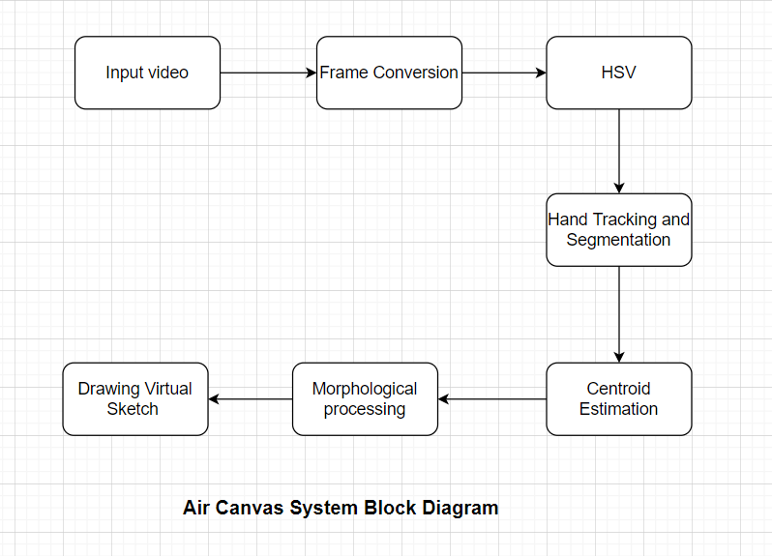

**Figure 2**

**3.1.2 Virtual Keyboard System:**

The various frameworks used for developing this model are opencv, image processing, image smoothing, low pass filter, etc.

**System Framework**

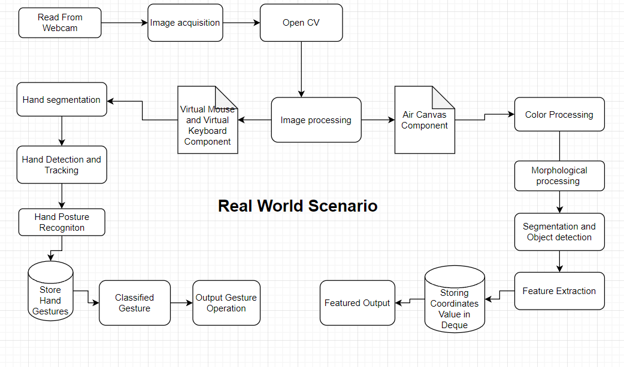

**Figure 5. System Framework Block Diagram**

**3.2 System Functionality**

* The Air canvas system is used to sketch, perform morphological operations and also includes different types of colors and shapes so that the user can directly use them by clicking on it or by picking and dragging them virtually.
* Virtual Keyboard System is used to perform keyboard operations like physical keyboard and functionality can be used anywhere in the window like on Browser, notepad, etc.
* Virtual Mouse System is used to perform cursor movement and click operation.

**CHAPTER 4 DESIGN AND METHODOLOGY**

**4.1 System Design**

**4.1.1 Air Canvas System**

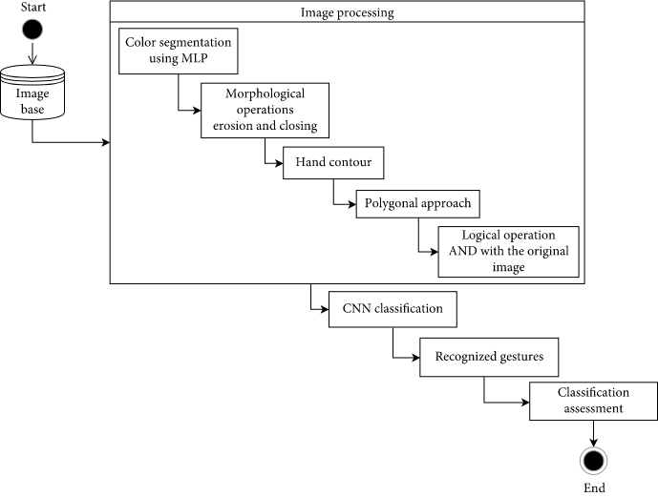

**Figure 6. Activity Diagram of Air canvas system**

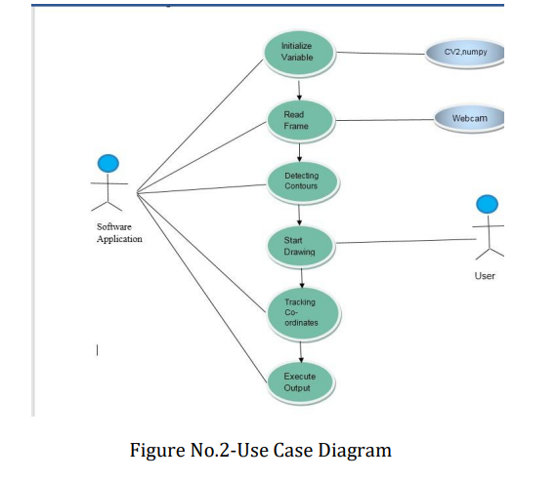

**Figure 7. Use case diagram of Air canvas System**

**Methodology for Air Canvas:**

* Using Air Canvas, you can draw anything on screen by just capturing the gesture of hand with a camera. In this project, we are using OpenCV computer vision methods.
* In order to achieve the goal, hand detection and tracking are utilized. A mask is created once the hand is identified.
* We have also given various color options like blue,red,yellow and green to draw and erase on the screen.
* It also includes a clear option to clear the screen.We has also added different types of elements like circle,rectangle,square,line and pen size to enhance user experience and interface.

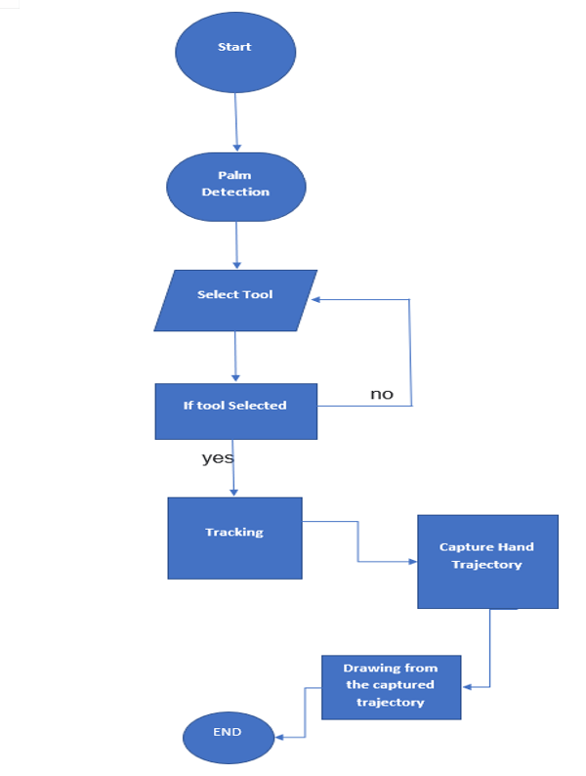

**Figure 8. Flow Chart of Air canvas System**

**Algorithm:**

* Begin reading the frames and converting them to the HSV color space. (Color detection is simple)
* Prepare the canvas frame and attach the appropriate ink buttons.
* To discover the coloured marker mask, change the trackbar values.
* Morphological operations(Dilation and Erotion)are used to preprocess the mask.
* Detect contours, locate the largest contour's centre coordinates, then store them in an array for subsequent frames.
* Points on the canvas are drawn using arrays.

**4.1.2 Virtual Keyboard and Mouse System**

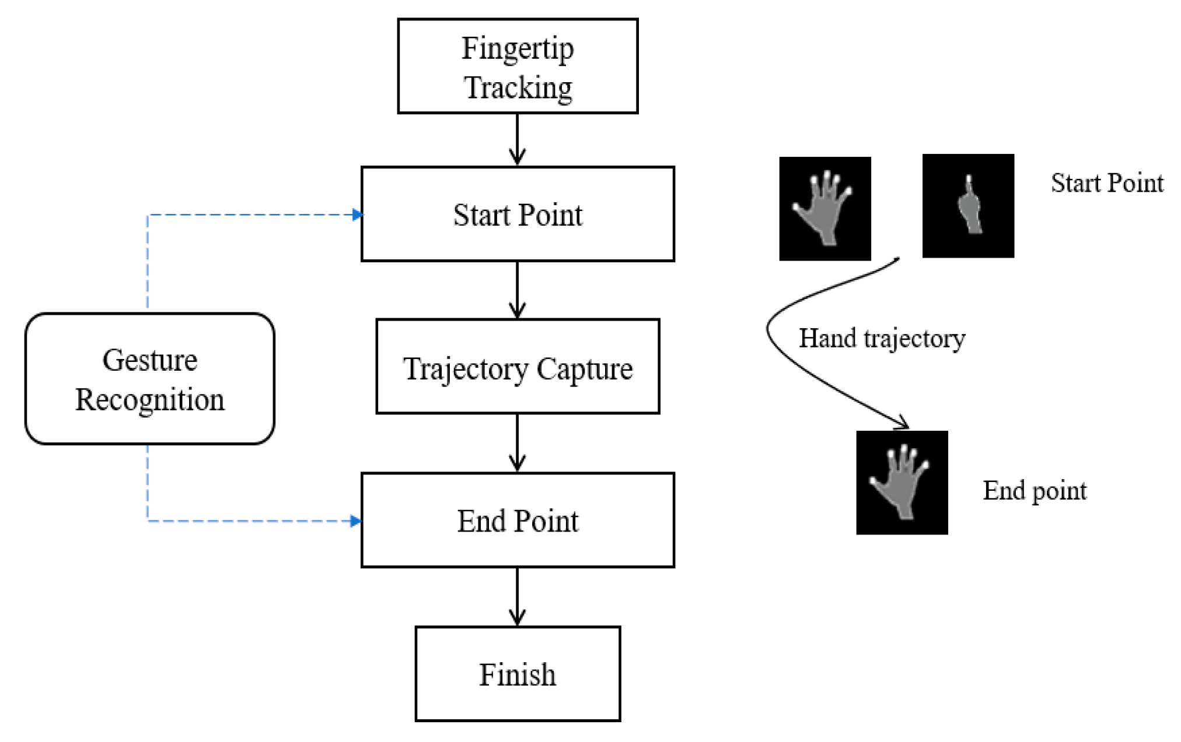

**Figure 9. Data Flow diagram of Virtual keyboard and mouse System**

**Methodology For Virtual Keyboard and Mouse system.**

* The camera will start taking the input from the webcam.
* Using the hand detection module of OpenCV library,we will track the hands.It will also track the landmarks on hands.
* The characters are displayed on the screen as buttons.
* If the distance between the fingers is less than a specific distance then click operation will be performed.
* The text will be displayed wherever the cursor is pointed on the screen.

**OpenCV**

OpenCV is a computer vision framework ,which plays a critical role in real-time operations. It may be used to detect items, faces, and even human handwriting in photos and movies. Python can process the OpenCV array structure for analysis when it is combined with other modules such as NumPy. We employ vector space and execute mathematical operations on these features to identify visual patterns and their various features.

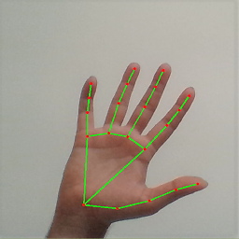

**Figure 3**

**The figure 3 shows the real time use of OpenCV in hand tracking.**

**Image Processing**

Image processing is the process of converting an image to a digital format and then conducting operations on it to extract valuable information. When implementing specific signal processing algorithms, the image processing system typically interprets all images as 2D signals.

There are five main types of image processing:

* Visualization - Look for objects in the image that aren't visible.
* Recognition - Identifying or detecting things in an image.
* Sharpening and restoration - Creating an upgraded image from the original image.
* Pattern recognition - Recognize the patterns that surround the things in the image.
* Retrieval - Search and browse through a database of digital photos that are comparable to the original image.

**Fundamental Image Processing Steps:**

### Image Acquisition

The initial stage in image processing is image acquisition. In image processing, this stage is also known as preprocessing. It entails getting the image from a source, which is usually hardware.

### Image Enhancement

Image enhancement is the process of bringing out and highlighting certain features of interest in an image that has been obscured. This can involve changing the brightness, contrast, etc.

**Image Restoration**

The technique of improving the appearance of an image is known as image restoration. Picture restoration, unlike image augmentation, is done using mathematical or probabilistic models.

### Color Image Processing

In the digital domain, colour image processing encompasses a variety of colour modelling techniques. Because of the widespread usage of digital photos on the internet, this step has acquired popularity.

### Wavelets and Multiresolution Processing

Wavelets are a type of visual representation that comes in a variety of resolutions. For data compression and pyramidal representation, the images are separated into wavelets or smaller sections.

### Compression

Compression is a technique for reducing the amount of storage or bandwidth needed to save or transmit an image. This is especially true when the photograph will be used on the Internet.

### Morphological Processing

Morphological processing is a collection of techniques used to morph images based on their forms.

### Segmentation

One of the most difficult aspects of image processing is segmentation. It entails breaking down an image into its component elements or objects.

### Representation and Description

Each region of an image is represented and described in a manner appropriate for further computer processing once it is segmented into regions in the segmentation process. The qualities and regional properties of an image are dealt with in representation. The task of description is to extract quantitative information that can be used to distinguish one class of things from another.

### Recognition

Recognition assigns a label to an object based on its description.

**Image Smoothing**

Image Smoothing is a technique for reducing image noise. Image smoothing is a significant image improvement approach for removing noise from images. As a result, it is a required functional module in many image-processing programmes. Image smoothing is a technique for enhancing image quality. Spatial and frequency filters are used to smooth the data.

**Low pass filters**

A low-pass filter (LPF) is an audio signal processor that filters out undesired frequencies above a preset cutoff frequency. It gradually filters out (attenuates) the high-end above its cutoff frequency while letting the low-end to pass through with few modifications, ideally.

The virtual keyboard uses a gesture based hand recognition system to track and detect hands. The further operations are performed using various Artificial Intelligence libraries and machine learning algorithms. The different hand landmarks are shown below.

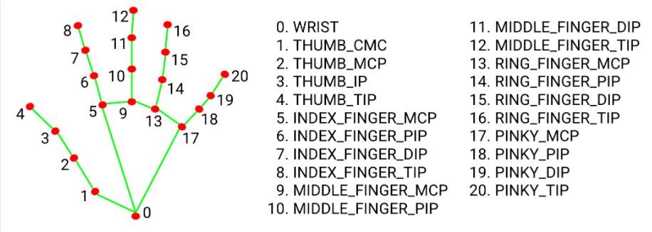

**Figure 4. Hand Landmark Model**

**3.1.3 Virtual Mouse System**

This system uses computer vision techniques such as Hand recognition and artificial intelligence libraries like mediapipe, numpy , autopy to perform mouse operations.

**Mediapipe**

For live and streaming media, MediaPipe offers open source cross-platform, configurable ML solutions.

**NumPy**

NumPy (numerical Python) is a library that consists of multidimensional array objects and a collection of functions for manipulating them. NumPy allows you to conduct mathematical and logical operations on arrays.

**AutoPy**

AutoPy is a Python GUI automation package that is simple and cross-platform. It has controls for the keyboard and mouse, as well as features for finding colors and bitmaps on the screen and showing alarms.

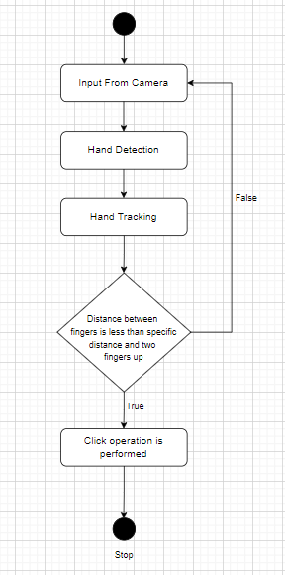

**Figure 10. Flow Chart of Virtual keyboard and mouse System**

**4.2 Hardware and Software Requirements**

* Operating System : Any Operating System
* Supporting software : Python,Numpy,Opencv
* Processor : Intel Core i5 7th Gen 2.50GHz
* RAM : 8GB
* Monitor : Monitor with webcam feature

**CHAPTER 5. RESULTS AND DISCUSSIONS**

**Screenshots of the working system:**

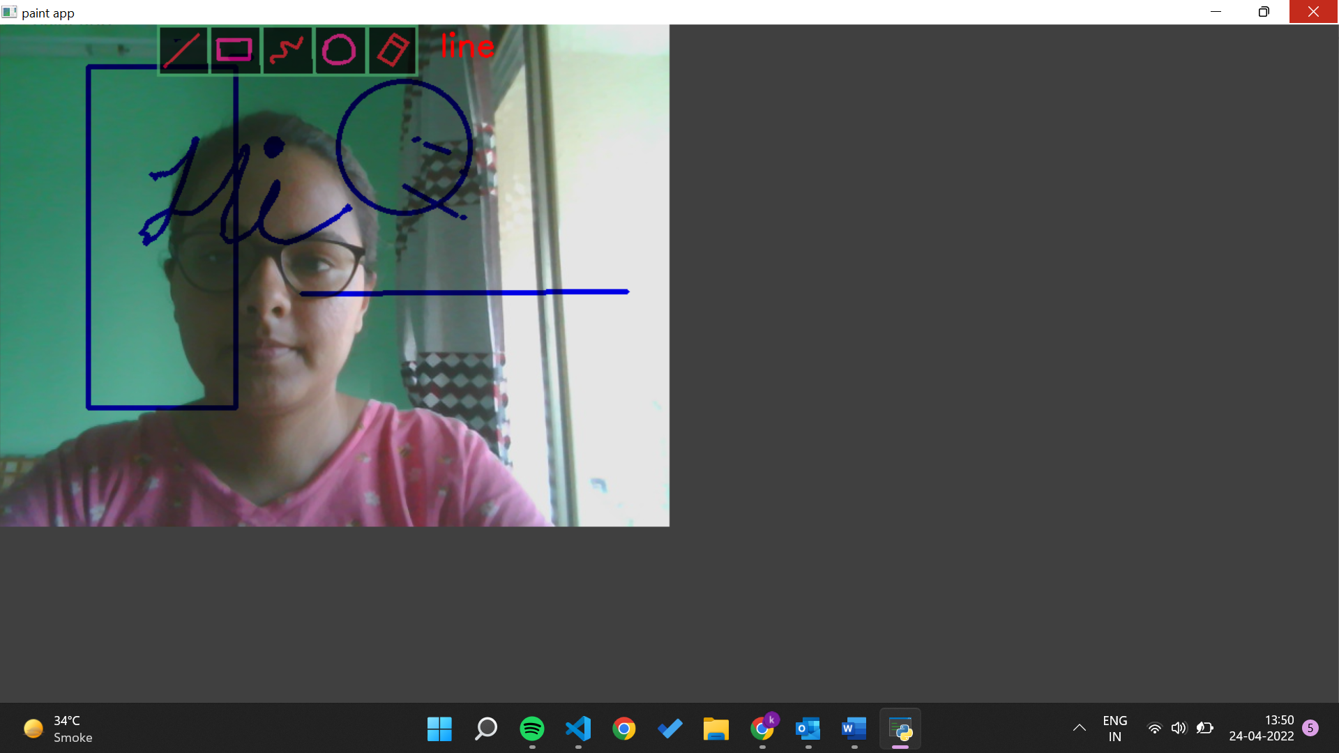

**Figure 11**

Figure 11. demonstrates our air canvas project with a sample virtual sketch displayed on the output screen. It has features like different color options for sketching virtually, adjusting pen size, along with eraser and clear option.

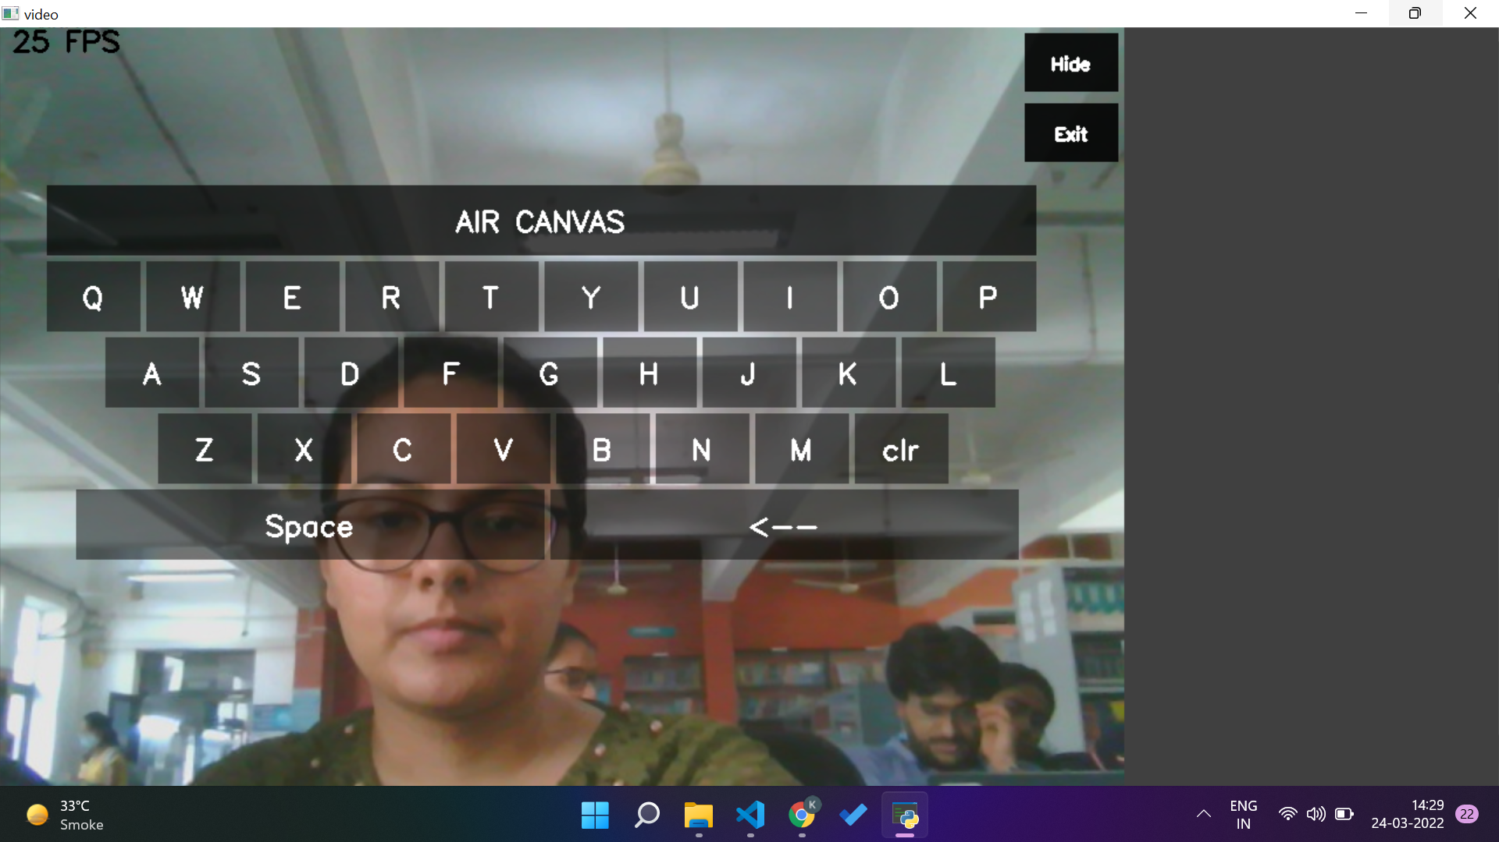

**Figure 12**

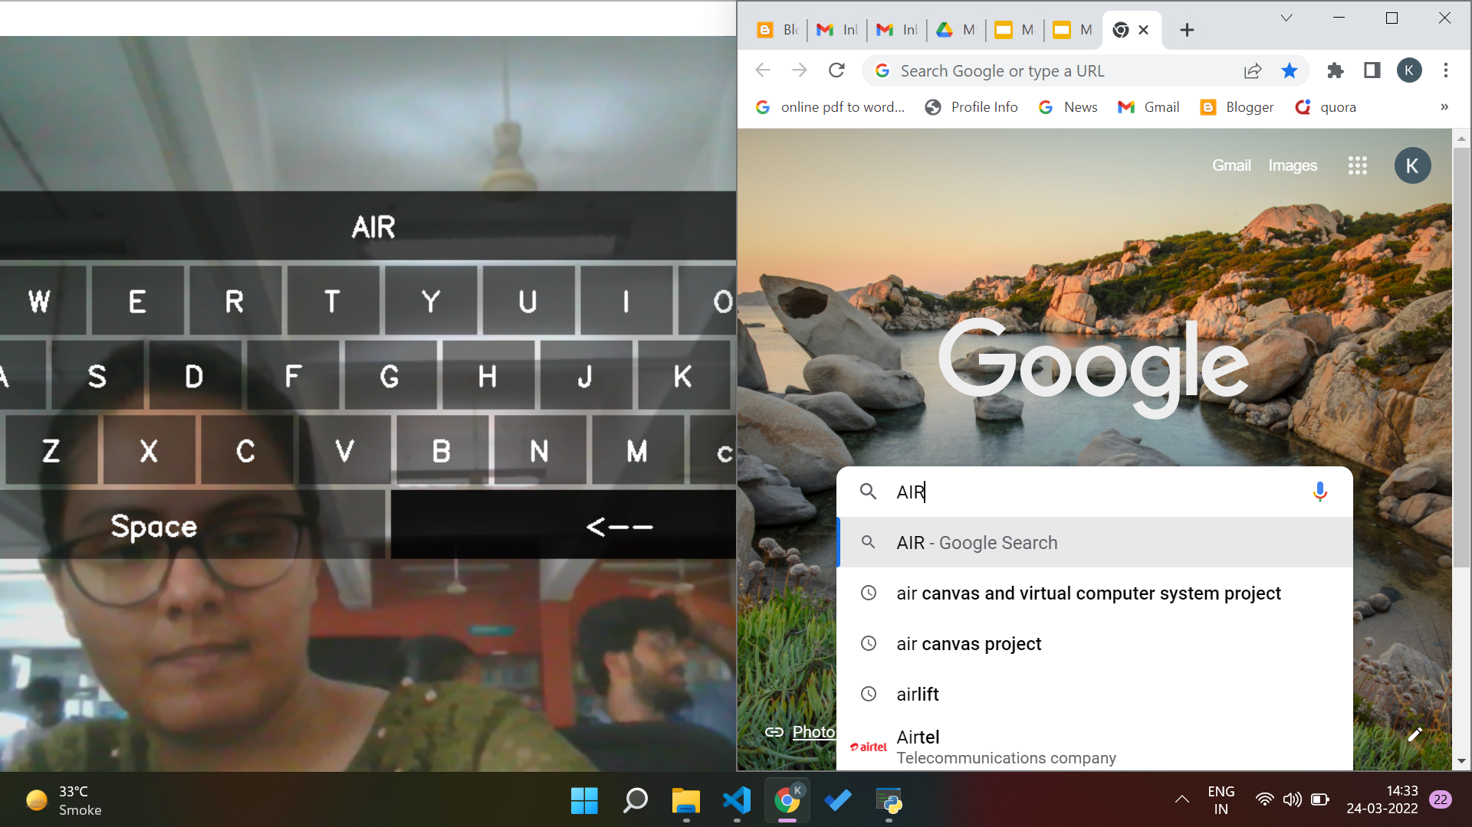

**Figure 13**

The figure 13 demonstrates our Virtual Keyboard system.Using Hand Gesture Recognition technique and various other algorithms of our system, when we perform hand gesture movement in front of the screen, the action is performed accordingly and we are able to write in the browser virtually.

**CHAPTER 6 CONCLUSION AND FUTURE SCOPE**

**6.1 Conclusion**

The coming era is of smart tech where tools like Air Canvas and Virtual Computer Systems hold high potential to replace and overcome the inefficiency and loopholes of conventional systems.This will not only save space and time but also improve human-machine interaction and bring better quality of life. The evolution can be as big as making the devices user friendly even for the disabled. In this System, we devised a digital computer application inclusive of mouse and keyboard manipulation together with a digital art tool as Air Canvas.

But, there continues to be a scope of improvement for and need of efficiency, in addition to a few high-quality features.

**6.2 Future Scope**

* Further this technology can be extended to home automation by controlling switch boards such as lights on or off with the gesture.
* Text to Speech feature- specially designed for physically impaired.
* Keyword to image (from web) for better demonstration of concepts and ideas.
* Build Robotic arms and other useful objects which can be visually controlled using gestures.
* 3D view and rotation of the objects with the help of which Augmented reality of 3D objects can be achieved.
* Features such as enlarging and shrinking windows, closing windows, by using the palm and multiple fingers.
* Voice recognition keyboard.
* Chatbot-for demonstration and assistance.

**REFERENCES**

1. Saoji, S. U., et al. "AIR CANVAS APPLICATION USING OPENCV AND NUMPY IN PYTHON." (2021).
2. Baig, Faisal, Muhammad Fahad Khan, and Saira Beg. "Text writing in the air." Journal of Information Display 14.4 (2013): 137-148.
3. Yash Patil, Mihir Paun, Deep Paun, Karunesh Singh, Vishal Kisan Borate, "Virtual Painting with Opencv Using Python", International Journal of Scientific Research in Science and Technology (IJSRST), Online ISSN : 2395-602X, Print ISSN : 2395-6011, Volume 5 Issue 8, pp. 189-194, November-December 2020.
4. Riza Sande, Neha Marathe, Neha Bhegade, Akanksha Lugade, Prof. S. S. Jogdand “Virtual Mouse using Hand Gestures “ International Journal of Advanced Research in Science, Engineering and Technology Vol. 8, Issue 4 , April 2021
5. Jain, Ayush, and Monika Verma. "An Implementation of Virtual Reality Application of Cursor Control Using Webcam.
6. Gupta, Dipankar, et al. "An Interactive Computer System with Gesture-Based Mouse and Keyboard." International Conference on Intelligent Computing & Optimization. Springer, Cham, 2020.
7. Thomas, Joseph. "A Camera Based Virtual Keyboard with Touch Detection by Shadow Analysis.’ (2013).
8. Nikhil Koul Pranav Nawathe Pranav Tulpule “Virtual Keyboard” International Journal of Scientific & Engineering Research, Volume 5, Issue 4, April-2014 650 ISSN 2229-5518
9. Wijewantha, Nadeeka Samanthi, and Chanaka Amarasekara. "VistaKey: A Keyboard Without A Keyboard–A Type Of Virtual Keyboard." Final year project thesis, Informatics Institute of Technology, Wellawatta, Sri Lanka (2004).
10. Varun, Kollipara Sai, I. Puneeth, and T. Prem Jacob. "Virtual Mouse Implementation using OpenCV." 2019 3rd International Conference on Trends in Electronics and Informatics (ICOEI). IEEE, 2019.
11. Chetan Chilhate, Priyanka D Patharwat, Shriyanka Agarwal, Vivek, Prof. Gauri. S. Bhange “Human Computer Interface Based Virtual Mouse” Vol-3 Issue-2 2017 IJARIIE-ISSN(O)2395-4396.
12. Prof. S.U. Saoji, Nishtha Dua, Akash Kumar Choudhary , Bharat Phogat “AIR CANVAS APPLICATION USING OPENCV AND NUMPY IN PYTHON” Volume-08 Issue-08, Aug 2021.
13. Pranavi Srungavarapu, Eswar Pavan Maganti, Srilekkha Sakhamuri, Sai Pavan Kalyan Veerada, Anuradha Chinta “Virtual Sketch using Open CV” International Journal of Innovative Technology and Exploring Engineering (IJITEE) ISSN: 2278-3075 (Online), Volume-10 Issue-8, June 2021.